***AI Agent Workflow: Scheduled News & Weather Briefing and Logging***

**Tools:**

**Docker:**

Docker Desktop provides the container runtime.

n8n runs as a container inside Docker.

You can access n8n via your browser and build workflows.

**n8n:**

n8n (pronounced “n-eight-n”) is an open-source workflow automation tool. Think of it as a bridge that connects apps, services, and databases so you can automate repetitive tasks without writing complex code. It’s similar in concept to tools like Zapier or Integromat, but with more flexibility and control because it’s open-source.

**Steps:**

**1. Schedule Trigger**

* + The workflow starts with a scheduled trigger.
  + This means the process will automatically start at predefined intervals (daily, hourly, etc.).

1. **AI Agent**
   * The trigger activates an **AI Agent**.
   * This agent is connected to:
     + **Google Gemini Chat Model** (for conversational AI and reasoning).
     + **Simple Memory** (to retain context or past interactions).
     + **Wikipedia** (as a tool for general knowledge queries).
     + **OpenWeatherMap** (to fetch current weather data).
     + **SerpAPI** (to fetch search results from the web).
   * Essentially, the AI Agent gathers information from these sources based on the scheduled task.
   * Since Ask AI Agent to collect the Weather report From OpenWeatherMap And News from Wikipedia.
2. **Markdown (Markdown to HTML)**
   * The AI’s output is then converted into **Markdown format**, which is later converted to **HTML**.
   * This step ensures the message is formatted properly before being sent.
3. **Message a Model**
   * The formatted content is then passed to a model (likely for refining or structuring the message).
   * Here,We are making the html into a styled html using inline css using this model.
4. **Send a Message (Gmail)**
   * After refinement, the output is sent as an **email message** using Gmail.
   * This allows automated daily/weekly reports, summaries, or alerts to be delivered to users.
5. **Message a Model 1**
   * After sending the email, the output is passed to another model for further processing (maybe summarization, structuring, or logging).
   * Here It categotrize the data into date,trending news,sports news,political news and movie news .
6. **Append Row in Google Sheets**
   * Finally, the workflow stores the generated and processed information in a **Google Sheet**.
   * This provides a structured history/log of all the messages or reports generated.

Output: 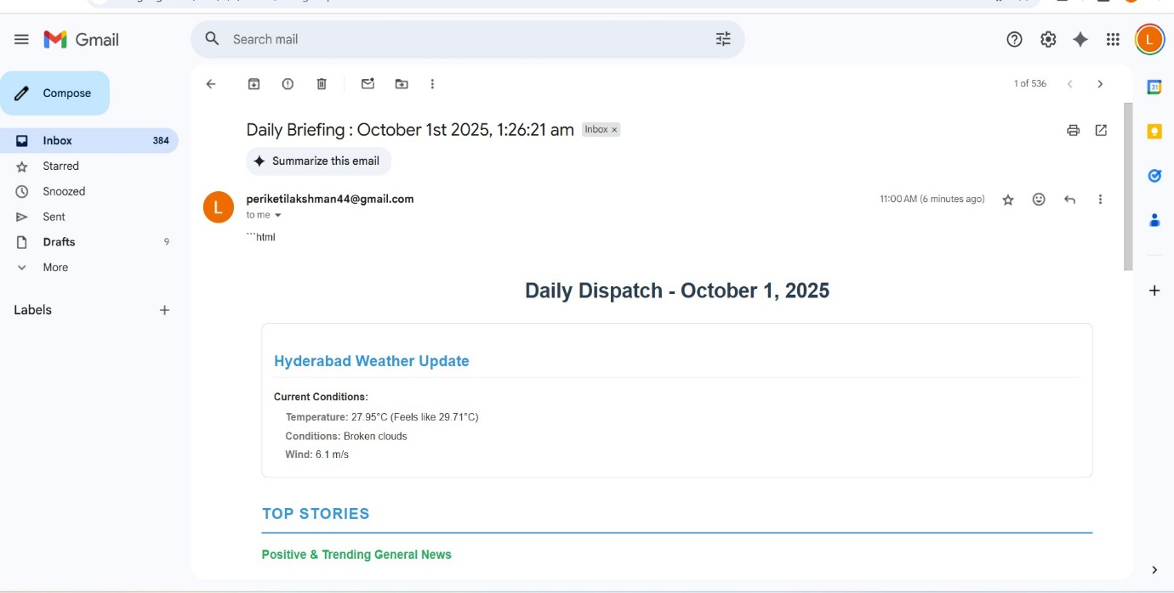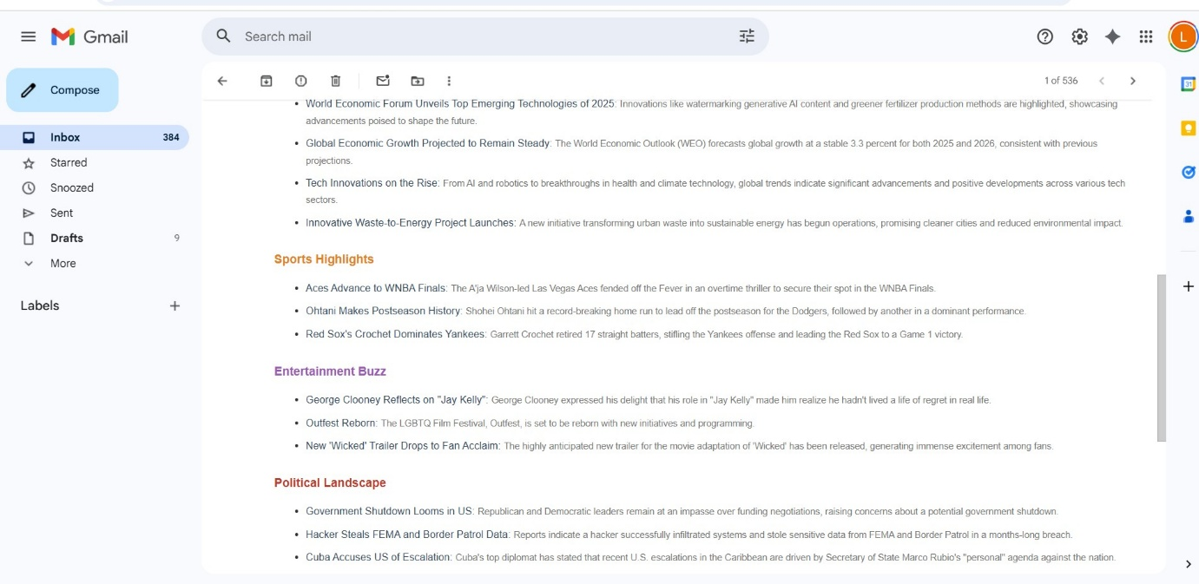

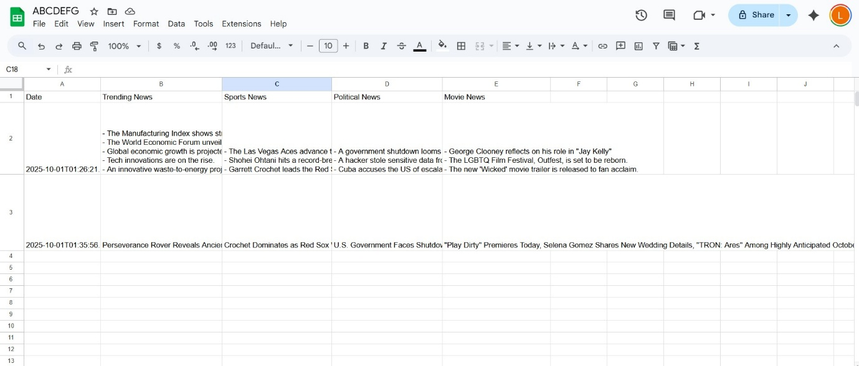

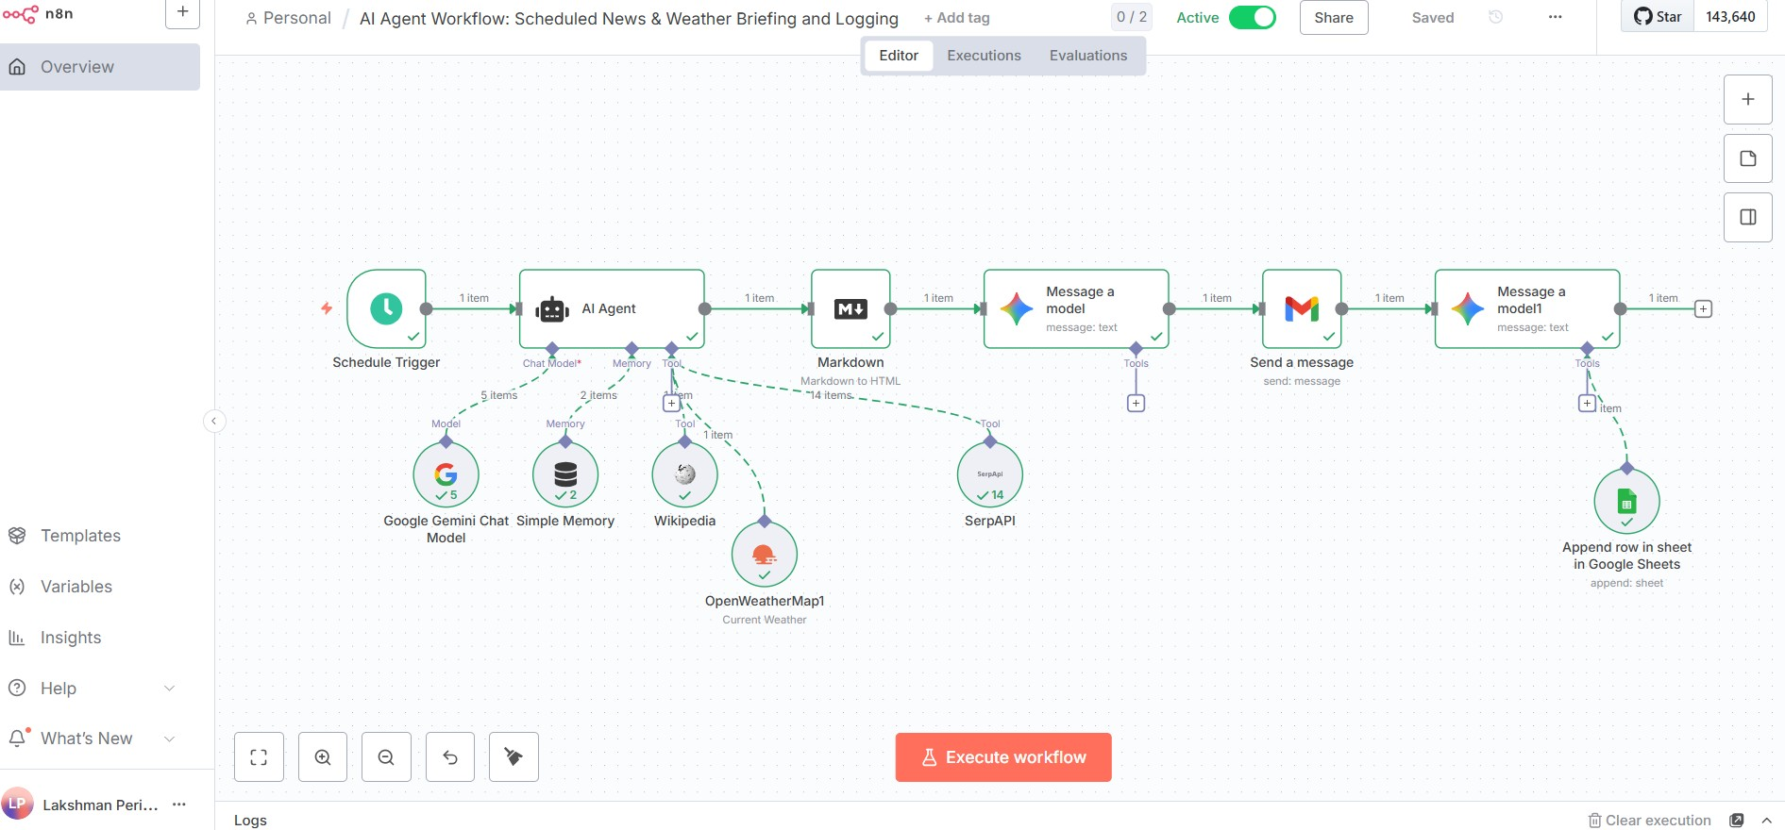

Lakshman

24071A05J6 CSE C